COMPUTER NETWORKS LAB
TASK 3
IPv4 PACKET INSPECTION
USING WIRESHARK
Packet details • IP addresses • Header fields • TTL

Name | Kasireddy Srihitha
Roll Number | 2520030153
Section | Sec - 7

1. AIM
To inspect IPv4 packets in the supplied Wireshark capture file, record source and destination IP addresses and selected IPv4 header fields, identify the packet with the maximum IPv4 total length, and compare TTL values.

2. SOFTWARE / INPUT REQUIRED
- Wireshark network protocol analyser.
- Capture file: CN_Lab1.pcapng.
- Display filter used: ip.

3. PROCEDURE
- Open Wireshark and load CN_Lab1.pcapng.
- Enter ip in the Display Filter bar and press Enter. A green filter bar indicates that the filter is valid.
- Locate the Packet List pane and select the required IPv4 packet rows.
- In the Packet Details pane, expand Internet Protocol Version 4.
- Read and record the source IP, destination IP, header length, total length, TTL and identification field.
- Repeat the inspection for the five selected packets.
- Compare the total lengths to identify the maximum and compare the TTL values.

4. OBSERVATION TABLE
The following observations are taken from the IPv4 packet details shown in the screenshots captured during the lab activity.
Packet No. | Source IP | Destination IP | Header Length | Total Length | TTL | Identification
10 | 10.250.13.216 | 224.0.0.251 | 20 bytes | 317 bytes | 1 | 0x3a11 (14865)
11 | 10.250.19.142 | 224.0.0.251 | 20 bytes | 311 bytes | 1 | 0x41ee (16878)
14 | 10.250.19.118 | 239.255.255.250 | 20 bytes | 155 bytes | 4 | 0x91e0 (37344)
15 | 10.250.22.93 | 224.0.0.251 | 20 bytes | 328 bytes | 1 | 0x041c (1052)
18 | 10.250.11.201 | 224.0.0.251 | 20 bytes | 86 bytes | 255 | 0x5244 (21060)
Observation: Packet No. 15 has the largest IPv4 total length at 328 bytes. The selected packets show TTL values of 1, 4 and 255.

5. ANALYSIS
Maximum IPv4 total length: Packet No. 15 has the largest total length among the five inspected packets, at 328 bytes.
Different TTL values: Packets 10, 11 and 15 have TTL 1; Packet 14 has TTL 4; Packet 18 has TTL 255.

6. SCREENSHOT EVIDENCE

6.1 PACKET NO. 10
Source: 10.250.13.216 | Destination: 224.0.0.251 | Header length: 20 bytes | Total length: 317 bytes | TTL: 1 | Identification: 0x3a11 (14865)
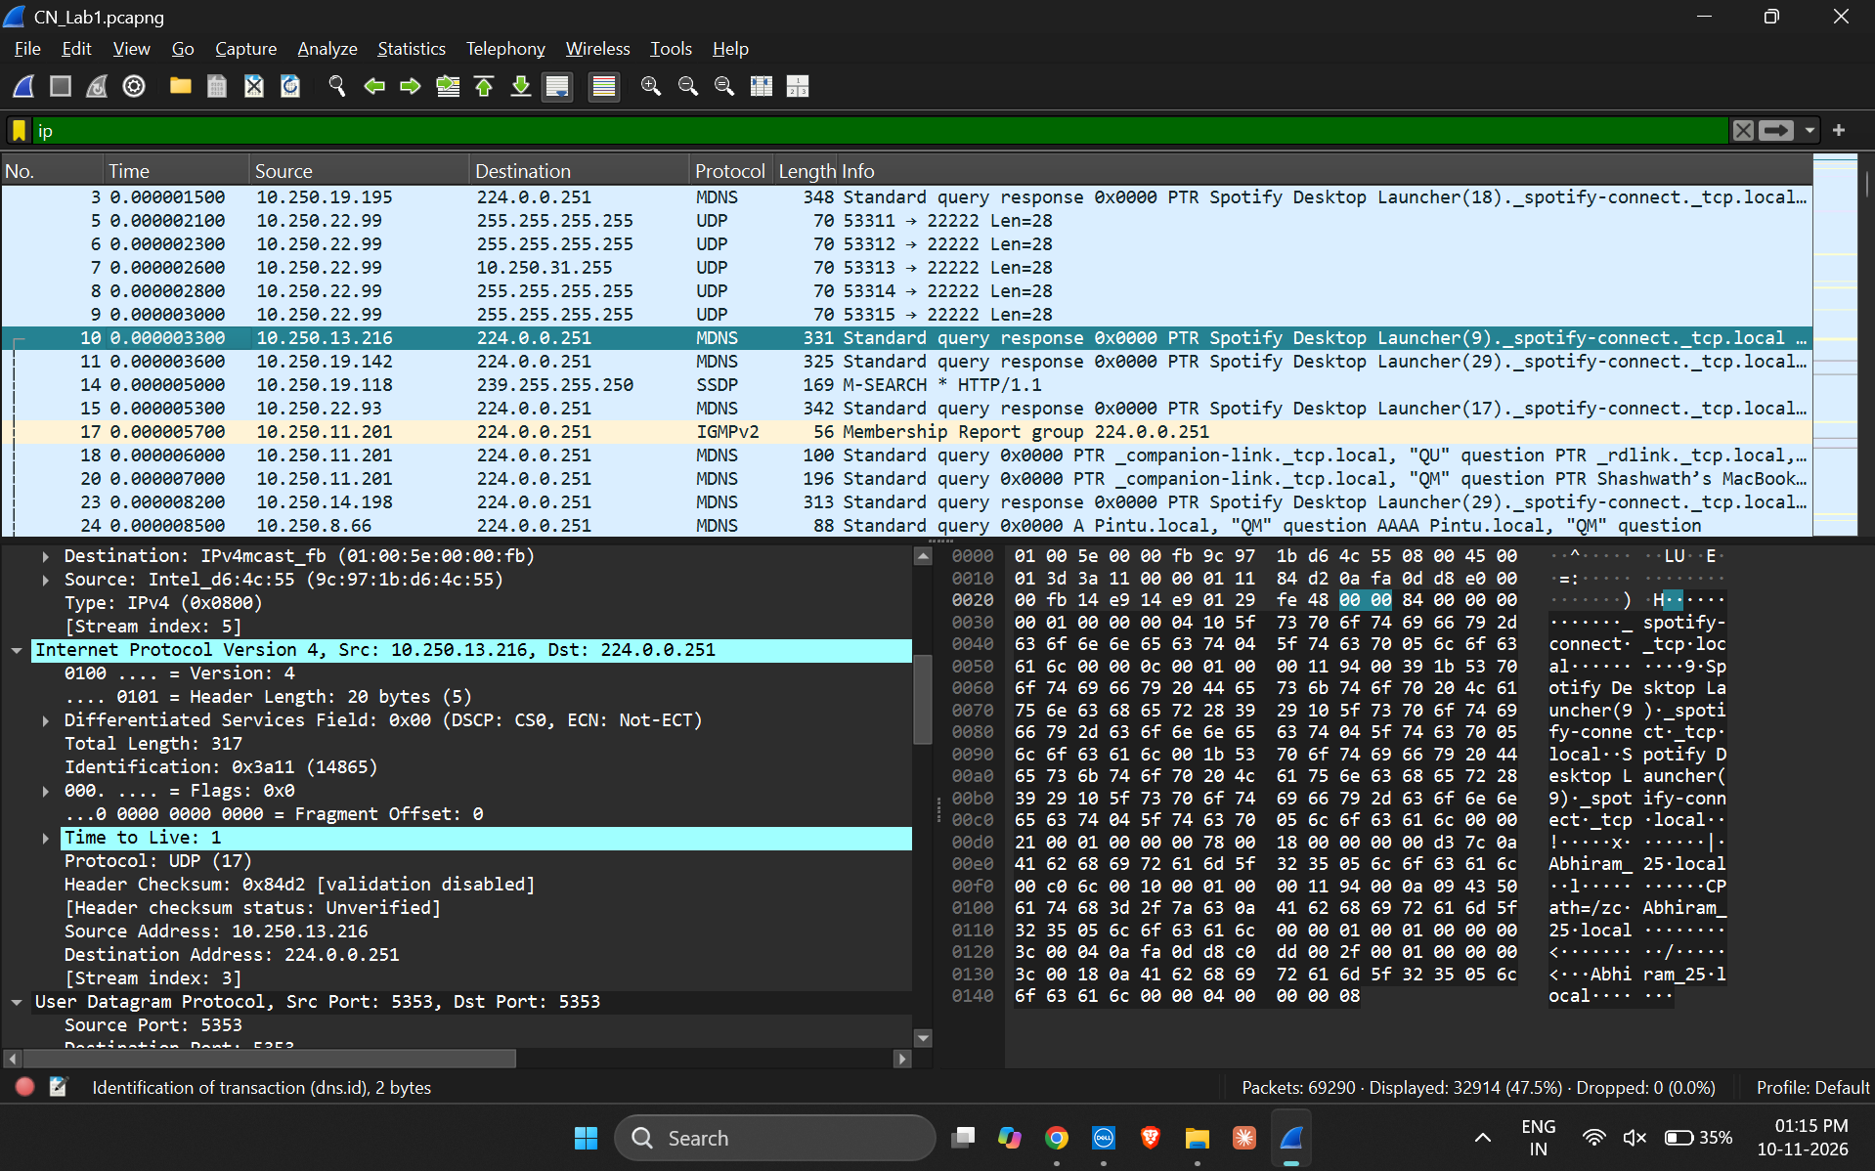

6.2 PACKET NO. 11
Source: 10.250.19.142 | Destination: 224.0.0.251 | Header length: 20 bytes | Total length: 311 bytes | TTL: 1 | Identification: 0x41ee (16878)
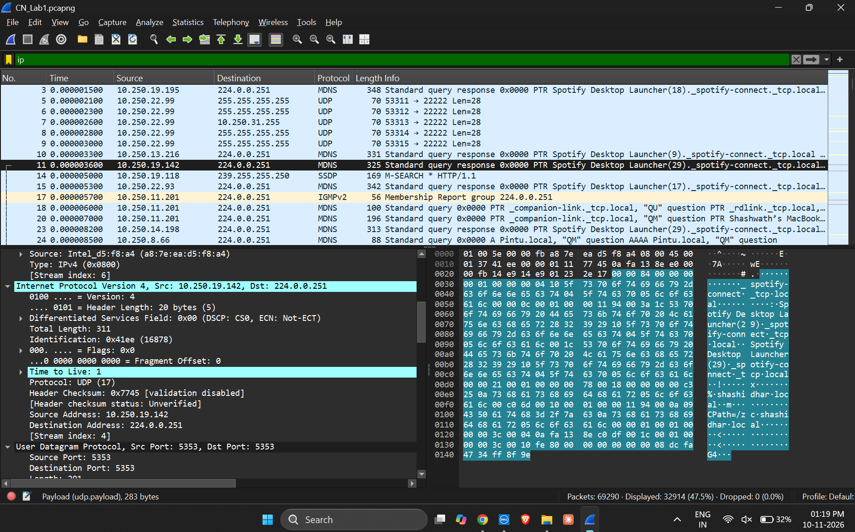

6.3 PACKET NO. 14
Source: 10.250.19.118 | Destination: 239.255.255.250 | Header length: 20 bytes | Total length: 155 bytes | TTL: 4 | Identification: 0x91e0 (37344)
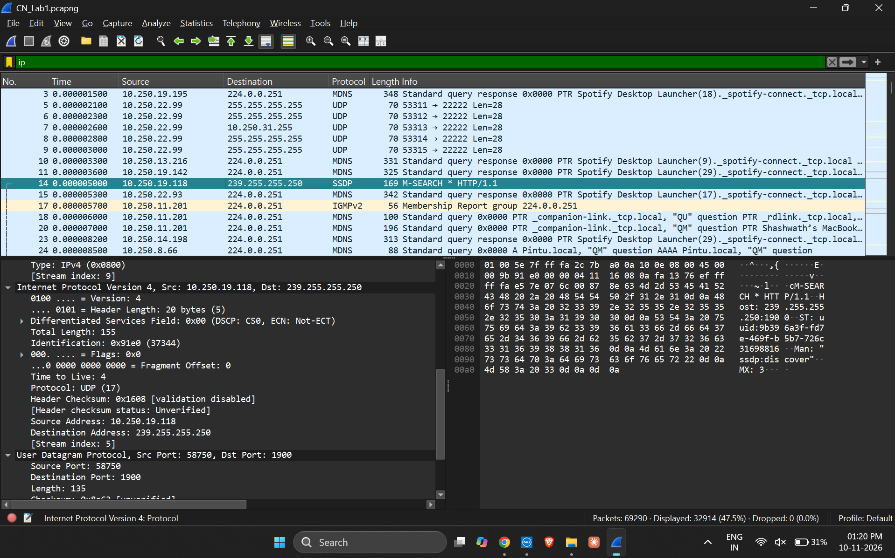

6.4 PACKET NO. 15
Source: 10.250.22.93 | Destination: 224.0.0.251 | Header length: 20 bytes | Total length: 328 bytes | TTL: 1 | Identification: 0x041c (1052)
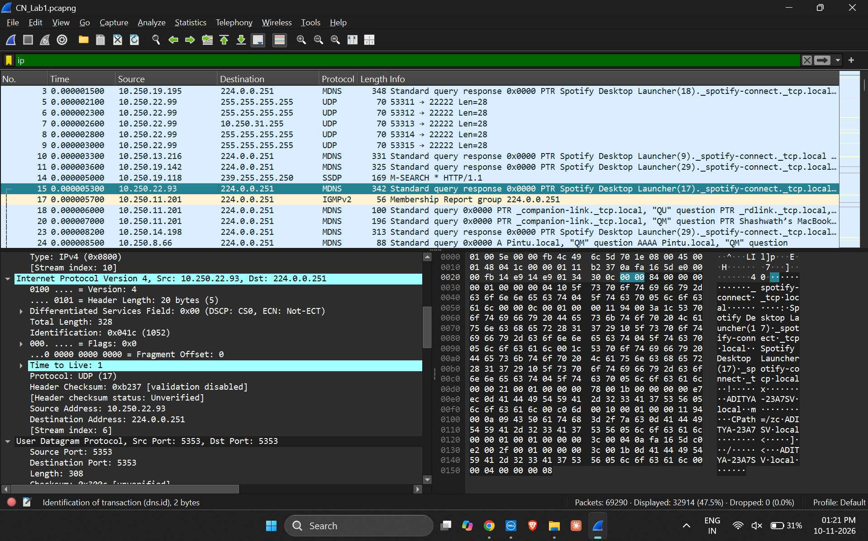

6.5 PACKET NO. 18
Source: 10.250.11.201 | Destination: 224.0.0.251 | Header length: 20 bytes | Total length: 86 bytes | TTL: 255 | Identification: 0x5244 (21060)
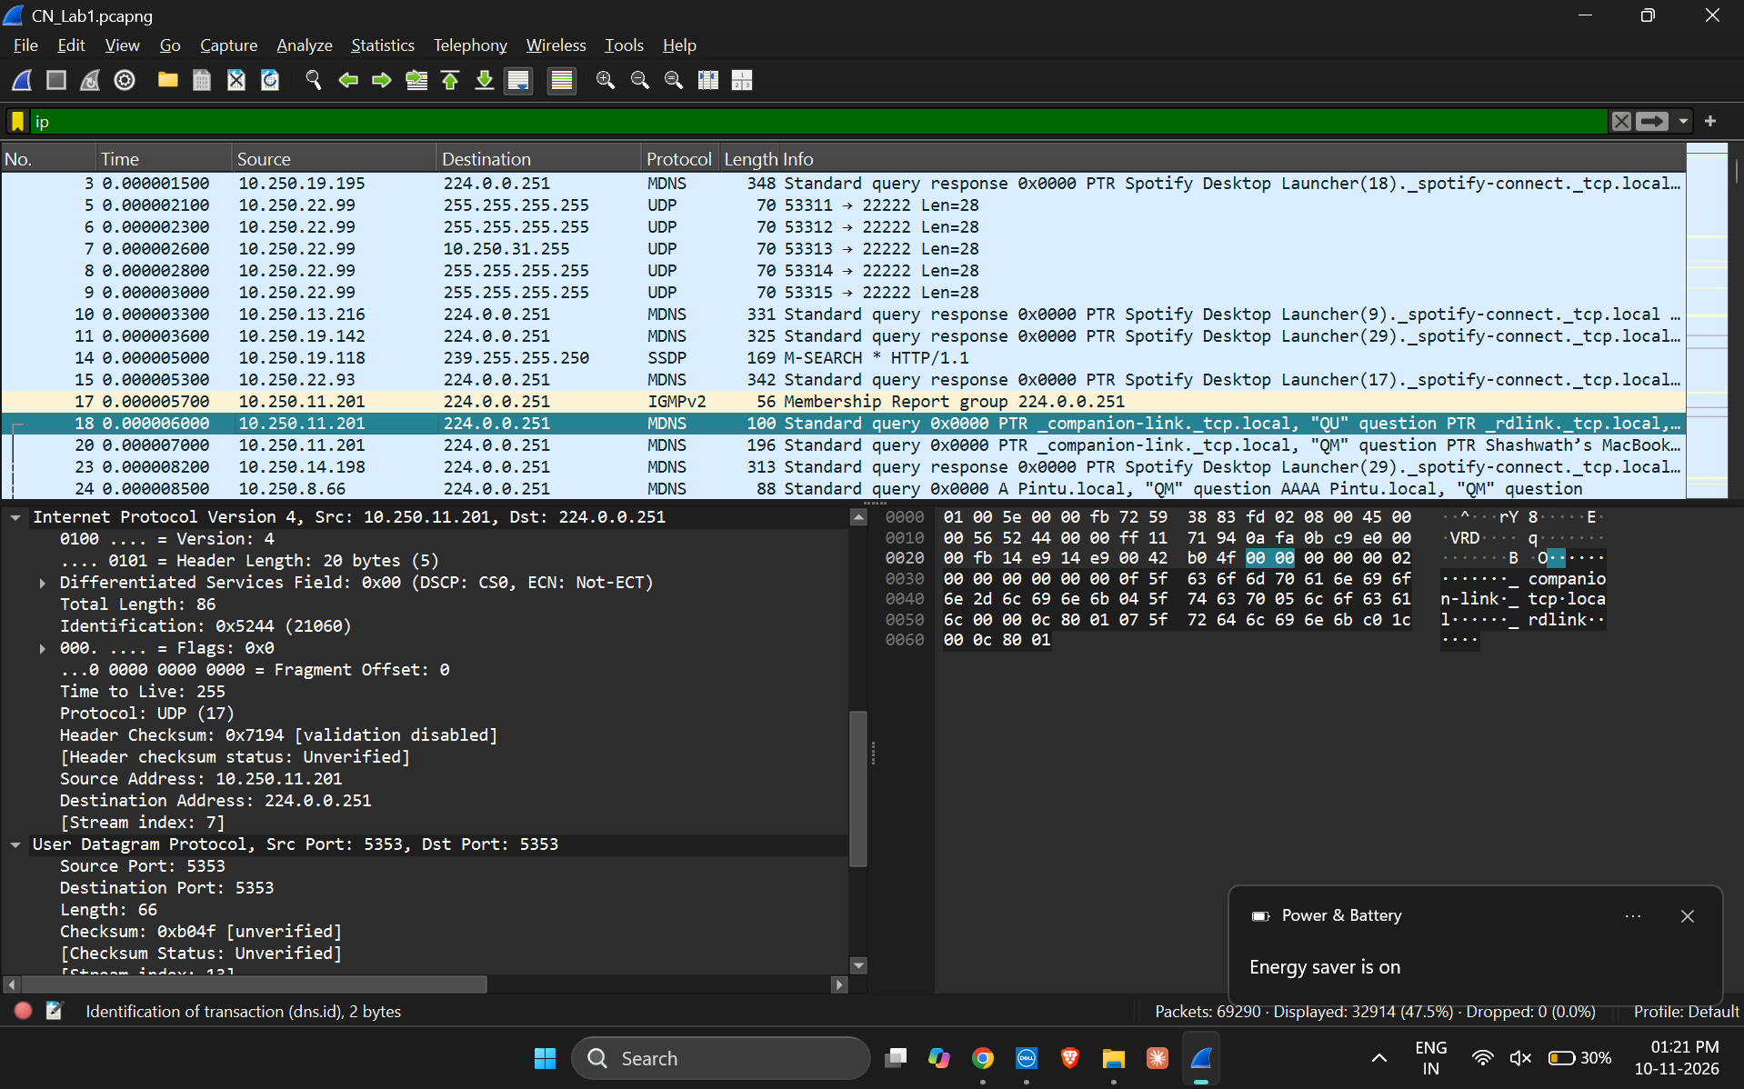

7. RESULT
IPv4 packet inspection was completed in Wireshark using the display filter ip. The required fields were recorded for five packets. Packet No. 15 has the maximum IPv4 total length of 328 bytes, and TTL values of 1, 4 and 255 were observed.

8. CONCLUSION
The activity demonstrated how to inspect the IPv4 header in Wireshark and record important fields such as source and destination IP addresses, header length, total length, TTL and identification. Comparing the selected packets helped identify the packet with the maximum total length and the different TTL values present in the capture.

9. FINAL CHECK
- Fill in the student name, roll number, section and date on the cover page.
- Check that all five screenshots are visible and readable in the document.
- Save or export the completed report as required by the lab instructor.
- Keep the original CN_Lab1.pcapng file if the instructor requires the capture file along with the report.

